**静态路由的配置实验**

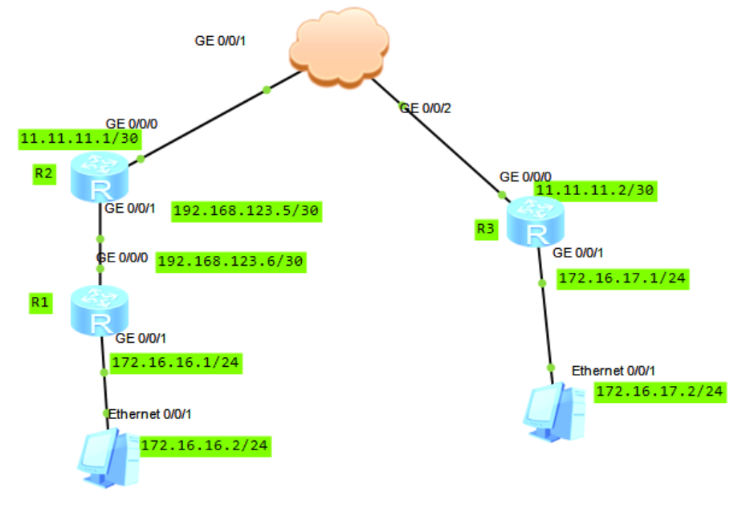

1、cloud的配置

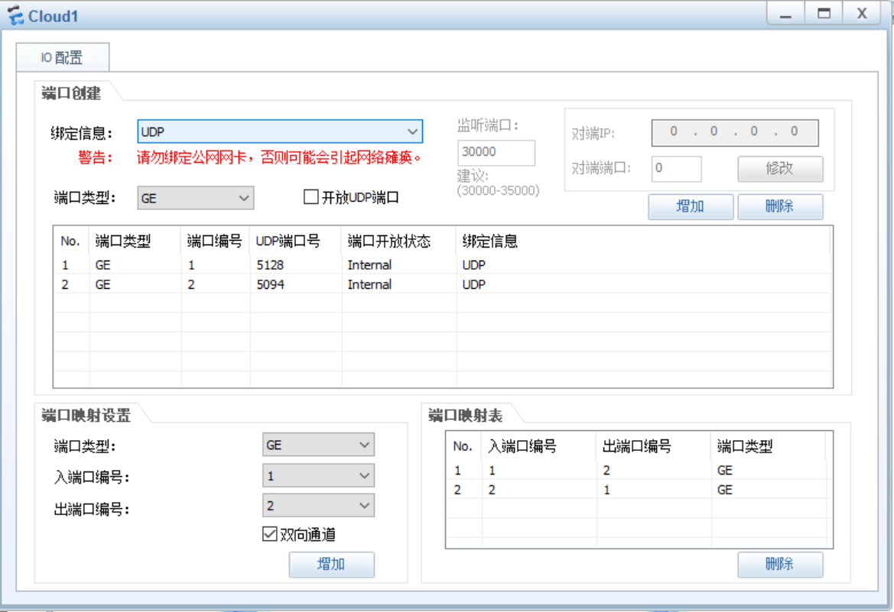

1. 搭建好拓扑结构，标识出各接口的IP地址，选中所有设备并启动设备

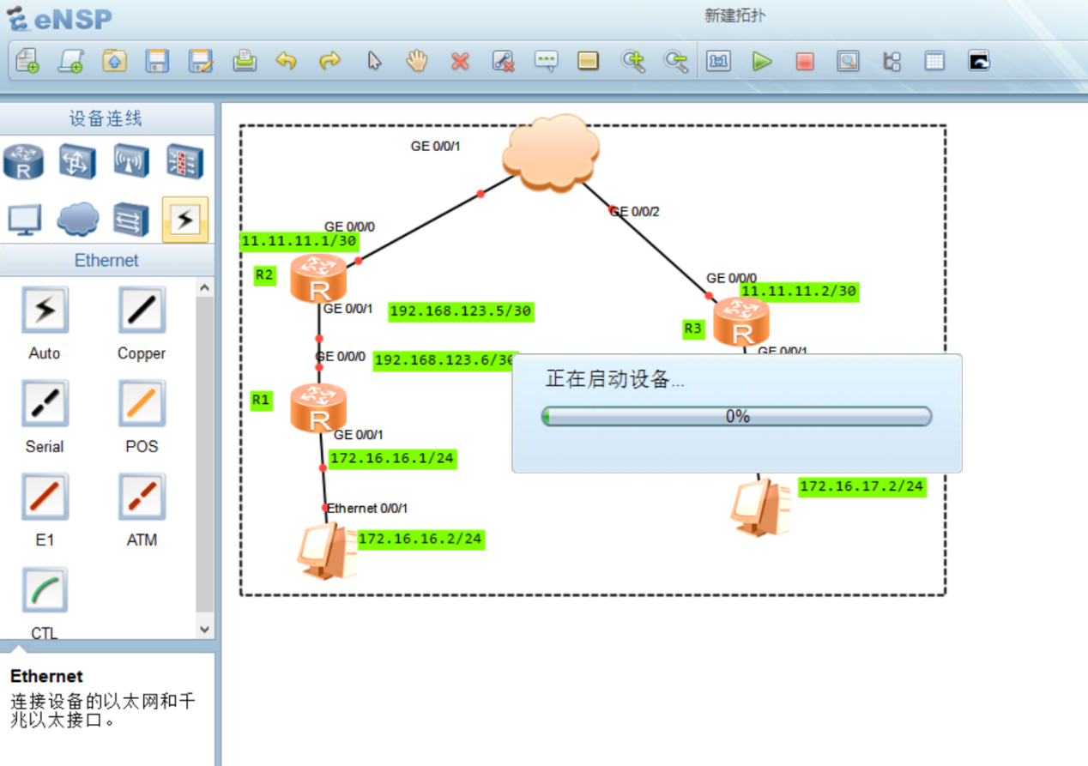

1. 配置接口IP地址

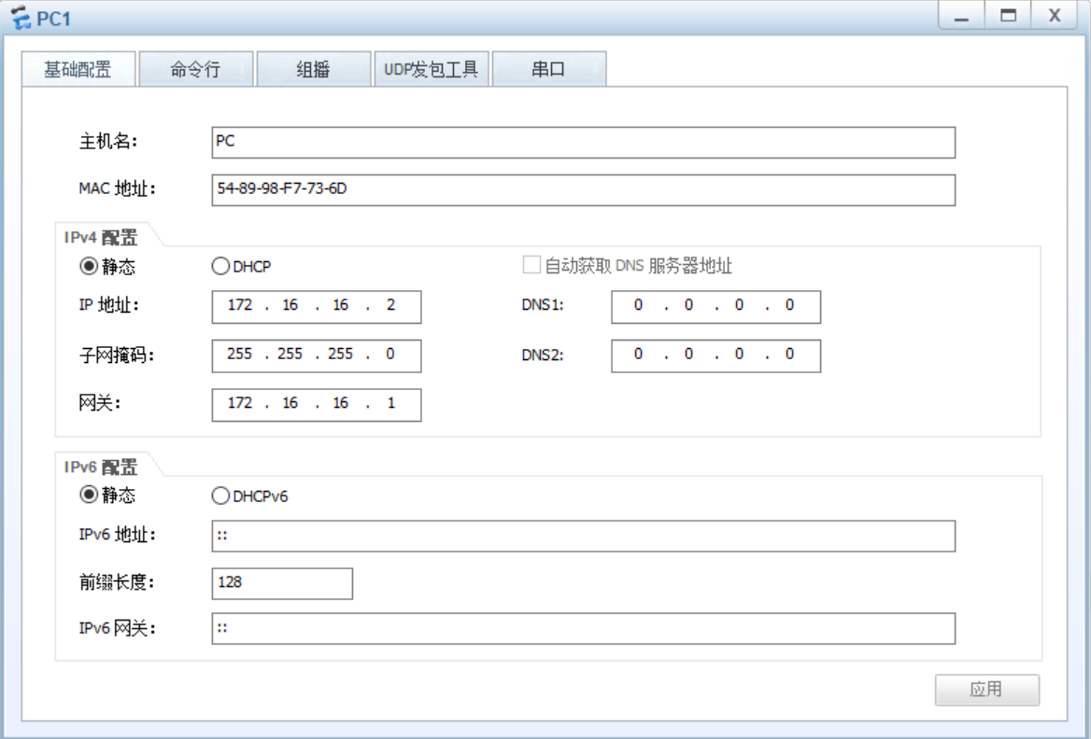

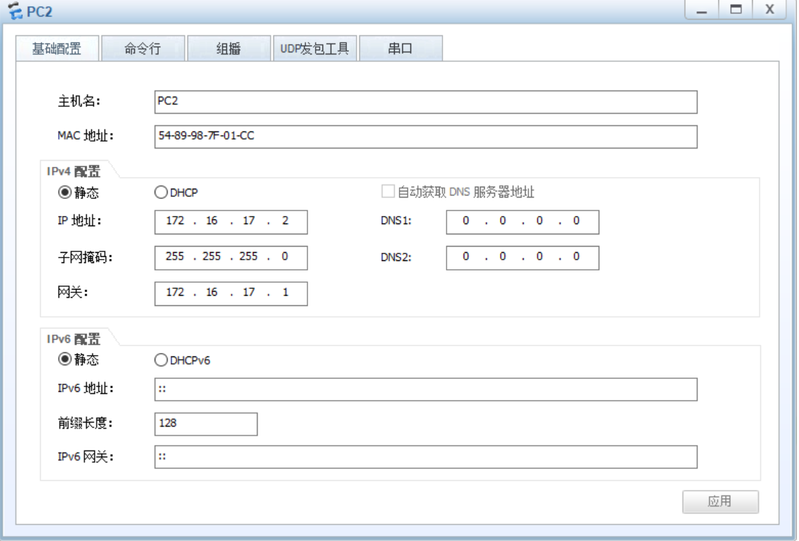



R1：

<Huawei>system-view

[Huawei]sysname R1 //修改路由器的名字为R1

[R1]interface GigabitEthernet 0/0/0 //进入接口G 0/0/0

[R1-GigabitEthernet0/0/0]ip address 192.168.123.6 30 //配置该接口的IP地址

[R1-GigabitEthernet0/0/0]quit

[R1]interface GigabitEthernet 0/0/1

[R1-GigabitEthernet0/0/1]ip address 172.16.16.1 24

[R1-GigabitEthernet0/0/1]quit

[R1]ip route-static 11.11.11.0 30 192.168.123.5

//配置到网络11.11.11.0/30的静态路由 ，下一跳地址为192.168.123.5

[R1]ip route-static 172.16.17.0 24 192.168.123.5

//配置到网络172.16.17.0/24的静态路由 ，下一跳地址为192.168.123.5

system-view

sysname R1

interface GigabitEthernet 0/0/0

ip address 192.168.123.6 30

quit

interface GigabitEthernet 0/0/1

ip address 172.16.16.1 24

quit

ip route-static 11.11.11.0 30 192.168.123.5

ip route-static 172.16.17.0 24 192.168.123.5

R2:

<Huawei>system-view

[Huawei]sysname R2

[R2]interface GigabitEthernet 0/0/0

[R2-GigabitEthernet0/0/0]ip address 11.11.11.1 30

[R2-GigabitEthernet0/0/0]quit

[R2-GigabitEthernet0/0/1]interface GigabitEthernet 0/0/1

[R2-GigabitEthernet0/0/1]ip address 192.168.123.5 30

[R2-GigabitEthernet0/0/1]quit

[R1]ip route-static 172.16.16.0 24 192.168.123.6

[R1]ip route-static 172.16.17.0 24 11.11.11.2

system-view

sysname R2

interface GigabitEthernet 0/0/0

ip address 11.11.11.1 30

quit

interface GigabitEthernet 0/0/1

ip address 192.168.123.5 30

quit

ip route-static 172.16.16.0 24 192.168.123.6

ip route-static 172.16.17.0 24 11.11.11.2

R3:

<Huawei>system-view

[Huawei]sysname R3

[R3]interface GigabitEthernet 0/0/0 11.11.11.2 30

[R3-GigabitEthernet0/0/0]ip address

[R3-GigabitEthernet0/0/0]quit

[R3-GigabitEthernet0/0/1]interface GigabitEthernet 0/0/1

[R3-GigabitEthernet0/0/1]ip address 172.16.17.1 24

[R3-GigabitEthernet0/0/1]quit

[R3]ip route-static 172.16.16.0 24 11.11.11.1

[R3]ip route-static 192.168.123.4 30 11.11.11.1

system-view

sysname R3

interface GigabitEthernet 0/0/0

ip address 11.11.11.2 30

quit

interface GigabitEthernet 0/0/1

ip address 172.16.17.1 24

quit

ip route-static 172.16.16.0 24 11.11.11.1

ip route-static 192.168.123.4 30 11.11.11.1